DATE: 29.11.2019
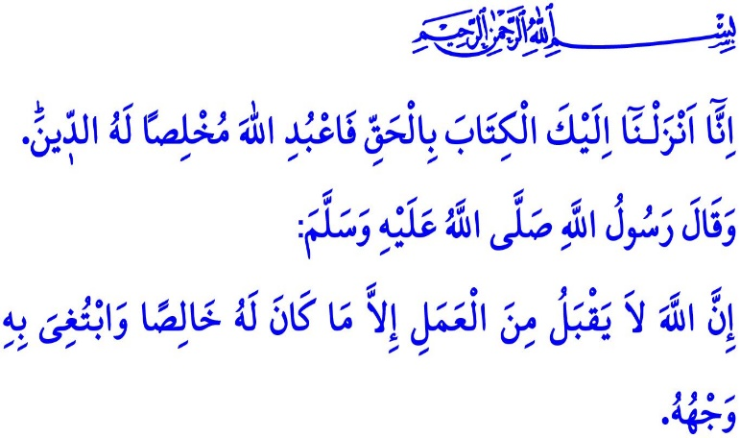
SINCERITY: THE ESSENCE OF FAITH
Honorable Muslims!
In the verse I have just recited the Almighty Allah (swt) states, “Indeed, We have sent down to you the Book in truth. So worship Allah, offering Him sincere devotion.”
In this respect, the Prophet Muhammad (saw) says, “Allah does not accept any deed except that which is purely for Him and for His sake.”
Dear Believers!
The essence of the sublime religion Islam is sincerity. Whether or not our words and actions have any value before Allah (swt) depends on our sincerity. Sincerity is to have heartfelt faith in Allah (swt) and to live a life seeking His approval only, without expecting any worldly benefit in return, as required by such faith. It is to treat in good way and intention all living and non-living beings. It is to either seem as you are or be as you seem.
Dear Muslims!
In one occasion the Prophet Muhammad (saw) said,  “Religion is sincerity.” When his companions asked “To whom, o Rasulullah?”, he replied, “To Allah, to His Book, to His Messenger, to the leaders (imams) of the Muslims, and to all Muslims.”
Religion should remind us of sincerity, as we understand from his words. It is not possible to view Islam as apart from ikhlas (purity), sincerity, good faith, and clean hearts.
Muslims worship Allah (swt) sincerely. They worship Him alone, they pray Him alone, and they ask for His help alone. They adhere to the Holy Qur'an, the best of words, sincerely. They strive to engrave the letter of the Qur'an in their memory, and implement its rules in their lives. They devote themselves to the Prophet Muhammad (saw) steadfastly. They, with deep love and sincerity, take him as a role model and try to live the way he did. They observe the rights of people in order for the establishment and prevalence of peace and security in the society in which they live. They uphold the truth, rule of law, and justice in all areas, from education to commerce and from family to broader circles of the society, under any circumstances. They sincerely fulfill their responsibilities towards all people in their environment, regardless of their title, gender, or age.
They are aware of the fact that each Muslim is an honorable member of the Prophet Muhammad's ummah. They treat generously all Muslims without discrimination on any ground such as gender, race, skin-color, or language. For them no profit is more valuable than arms wide open with brotherly feelings of affection and compassion, and sincere prayers uttered with brotherly sympathy.
Dear Believers!
Ostentation and show-off are the greatest reasons to cause people to be captives of their ambitions and to cast a shadow over their sincerity. Islam orders that our words and actions be free from any kind of deceit and far from any play of interests. It advises us to “do good in expectance of its outcomes from Allah only”. It makes clear that people who make concessions on honesty and sincerity and who think they derive benefits from people by deceiving them are actually doomed to lose. This is because all that those pretentious people will derive as benefit, who only seek to show off to others what they do, is loss in this world and in the Hereafter.
Dear Muslims!
In one occasion, the Prophet Muhammad (saw) warned us, “Allah does not look at your outward appearance and your wealth but He looks only at your hearts and your deeds.” Then, let us ensure that our hearts are clean and our deeds are sincere if we want to be decent Muslims and good servants of Allah (swt). Let us set getting the approval of Allah (swt) as the purpose of our lives. Let us never forget that He is All-Seeing and All-Knowing of what we do openly and secretly, and that He does and will reward our deeds if done sincerely only. Let us turn away from pomposity and hypocrisy. Let us all pray to Allah in the Prophet Muhammad's (saw) words, “O Allah, our Lord, and Lord of everything! Make me and my family sincere to You at every moment in this world and in the Hereafter. O Possessor of glory and honor!”

Zumar, 39/2.
Nasa'i, Jihad, 24.
Muslim, Iman, 95.
Muslim, Birr, 34.
Abu Dawud, Witr, 25. General Directorate of Religious Services

